Using Operations with Linear Equations

Complete the following problems.

- When $4x - 2$ is added to $-2x + 7$, the sum is:

- If $a = 11x – 5$ and $b = 2x + 3$, what is the value of$a + b$?

- Three consecutive numbers are added together and then their sum is multiplied by 4.
    - Some of the equations below represent the total using algebra. Circle all that apply.
Total = $4x + 4x + 1 + 4x + 2$ | Total= $4x + 4x + 4 + 4x + 8$
Total = $4x + 4(x + 1) + 4(x + 2)$ | Total= $x + x + 4 + x + 8$
    - Explain your answers.

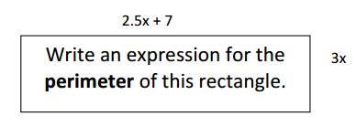

- Find the sum of $-\frac{41}{5}x+5$ and $-3\frac{3}{5}x+2$.

- When $-1.3x-4$ is subtracted from $-3x-5.6$, the result is:

- If $a = -4x + 9$ and $b = 7x – 8$, what is the value of $a – b$?

- The result of subtracting $-9x – 8$ and $-4.3x + 7$ is:

- What is the factored form of $63x - 9$?

- Expand $6(-\frac{13}{3}x+8)$?

- Sophia says that $-5(x – 3) + 2$ and $-5x + 17$ are equivalent. Do you agree? Explain by solving and showing your work.

- What is the area of the rectangle below?

- Write an expression for the sequence of operations.
    - Add 7 to x, subtract the result from 3, and then double what you have.

    - Add 3 to x, triple what you have, and then subtract 5 from the result.

